Description of Measures Used to Rank IR Scholars and Departments

Memo: Peter Campbell to M. Desch

5/21/2013

1. ***All Citations (All Cites)***
   1. Individual: This score represents the number of cites that an author received for articles published in a journal listed under “Social Sciences” by the Web of Science.
   2. Department: This score is an average calculated by summing all of the cites received for articles published in a journal listed under “Social Sciences” by the Web of Science and then dividing that number by the number of IR faculty members in the department.
2. ***All Citations Normalized (All Cites N)***
   1. Individual: This score is calculated by taking the scholars *All Cites* score and dividing it by the number of years since they received their PhD. In the case of scholars for which we had no CV, years since PhD was calculated from the year of their oldest article to 2013. The justification here is that the longer a scholar has been active the older their articles are and the more citations they will accumulate over time and the more journal articles they will have produced.
   2. Department: This score calculated by summing the *All Cites N* for each member of the department and dividing it by the number of IR faculty members in the department. This is an attempt to control for the size of departments.
3. ***All h-index (All h-index)***
   1. Individual: This score represents the h-index generated by the distribution of citations that an author received for articles published in a journal listed under “Social Sciences” by the Web of Science. The h-index differs from a citation count because it is determined not only by the number of cites received but the distribution of those cites. Two scholars could have the same number of citations, but the scholar whose citations are distributed among a more diverse range of journals will have a higher h-index.
   2. Department: This score is calculated by summing all of the scholars’ h-indices for “Social Science” journals and dividing it by the number of IR faculty members in the department to produce an average h-index for the whole department.
4. ***All h-index Normalized (All Nh)***
   1. Individual: This score is calculated by dividing the h-index for articles published in a journal listed under “Social Sciences” by the number of years since the scholar received their PhD.
   2. Department: This score calculated by summing the *All Nh* for each member of the department and dividing it by the number of IR faculty members in the department.
5. ***Political Science and International Relations Citations (POLS+IR Cites)***
   1. Individual: This score represents the number of cites that an author received for articles published in a journal listed under both “Political Science” and “International Relations” by the Web of Science.
   2. Department: This score is an average calculated by summing all of the cites received for articles published in a journal listed under both “Political Science” and “International Relations” and then dividing that number by the number of IR faculty members in the department.
6. ***Political Science and International Relations Citations Normalized (POLS+IR Cites N)***
   1. Individual: This score is calculated by taking the scholars *POLS+IR Cites* score and dividing it by the number of years since they received their PhD.
   2. Department: This score calculated by summing the *POLS+IR Cites N* for each member of the department and dividing it by the number of IR faculty members in the department.
7. ***Political Science and International Relations h-index (POLS+IR h-index)***
   1. Individual: This score represents the h-index generated by the distribution of citations that an author received for articles published in a journal listed under both “Political Science” and “International Relations.”
   2. Department: This score is calculated by summing all of the scholars’ h-indices for both “Political Science” and “International Relations” and dividing it by the number of IR faculty members in the department to produce an average h-index for the whole department.
8. ***Political Science and International Relations h-index Normalized (POLS+IR Nh)***
   1. Individual: This score is calculated by dividing the *POLS+IR h-index* by the number of years since the scholar received their PhD.
   2. Department: This score calculated by summing the *POLS+IR Nh* for each member of the department and dividing it by the number of IR faculty members in the department.
9. ***Political Science Citations (POLS Cites)***
   1. Individual: This score represents the number of cites that an author received for articles published only in journals listed under “Political Science” excluding journals that were also listed as “International Relations,” i.e. the overlap.
   2. Department: This score is an average calculated by summing all of the cites that an author received for articles published only in journals listed under “Political Science,” excluding journals that were also listed as “International Relations,” and then dividing that number by the number of IR faculty members in the department.
10. ***Political Science Citations Normalized (POLS Cites N)***
    1. Individual: This score is calculated by taking the scholars *POLS Cites* score and dividing it by the number of years since they received their PhD.
    2. Department: This score calculated by summing the *POLS Cites N* for each member of the department and dividing it by the number of IR faculty members in the department.
11. ***Political Science h-index (POLS h-index)***
    1. Individual: This score represents the h-index generated by the distribution of citations that an author received for articles published only in journals listed under “Political Science,” excluding journals that were also listed as “International Relations.”
    2. Department: This score is calculated by summing all of the scholars’ *POLS h-index* scores and dividing it by the number of IR faculty members in the department to produce an average h-index for the whole department.
12. ***Political Science h-index Normalized (POLS Nh)***
    1. Individual: This score is calculated by dividing a scholar’s *POLS h-index* by the number of years since the scholar received their PhD.
    2. Department: This score is calculated by summing the *POLS Nh* for each member of the department and dividing it by the number of IR faculty members in the department.
13. ***All International Relations Citations (All IR Cites)***
    1. Individual: This score represents the number of cites that an author received for articles published in journals listed under “International Relations” by the Web of Science, including journals that were also listed as “Political Science,” i.e. the overlap.
    2. Department: This score is an average calculated by summing all of *All IR Cites* for each scholar and then dividing that number by the number of IR faculty members in the department.
14. ***All International Relations Citations Normalized (All IR Cites N)***
    1. Individual: This score is calculated by taking the scholars *All IR Cites* score and dividing it by the number of years since they received their PhD.
    2. Department: This score calculated by summing the *All IR Cites N* for each member of the department and dividing it by the number of IR faculty members in the department.
15. ***All International Relations h-index (All IR h-index)***
    1. Individual: This score represents the h-index generated by the distribution of citations that an author received for articles published in journals listed under “International Relations” by the Web of Science, including journals that were also listed as “Political Science.”
    2. Department: This score is calculated by summing all of the scholars’ *All IR h-index* scores and dividing them by the number of IR faculty members in the department to produce an average h-index for the whole department.
16. ***All International Relations h-index Normalized (All IR Nh)***
    1. Individual: This score is calculated by dividing a scholar’s *All IR h-index* by the number of years since they received their PhD.
    2. Department: This score is calculated by summing the *All IR Nh* for each member of the department and dividing it by the number of IR faculty members in the department.
17. ***International Relations Exclusive Citations (IR Ex Cites)***
    1. Individual: This score represents the number of cites that an author received for articles published in journals listed under “International Relations” by the Web of Science, excluding journals that were also listed as “Political Science,” i.e. the overlap.
    2. Department: This score is an average calculated by summing all of *IR Ex Cites* for each scholar and then dividing that number by the number of IR faculty members in the department.
18. ***International Relations Exclusive Citations Normalized (IR Ex Cites N)***
    1. Individual: This score is calculated by taking the scholars *IR Ex Cites* score and dividing it by the number of years since they received their PhD.
    2. Department: This score calculated by summing the *IR Ex Cites N* for each member of the department and dividing it by the number of IR faculty members in the department.
19. ***International Relations Exclusive h-index (IR Ex h-index)***
    1. Individual: This score represents the h-index generated by the distribution of citations that an author received for articles published in journals listed under “International Relations” by the Web of Science, excluding journals that were also listed as “Political Science.”
    2. Department: This score is calculated by summing all of the scholars’ *IR Ex h-index* and dividing it by the number of IR faculty members in the department to produce an average h-index for the whole department.
20. ***International Relations Exclusive h-index Normalized (IR Ex Nh)***
    1. Individual: This score is calculated by dividing a scholar’s *IR Ex h-index* score by the number of years since the scholar received their PhD.
    2. Department: This score is calculated by summing the *IR Ex Nh* for each member of the department and dividing it by the number of IR faculty members in the department.

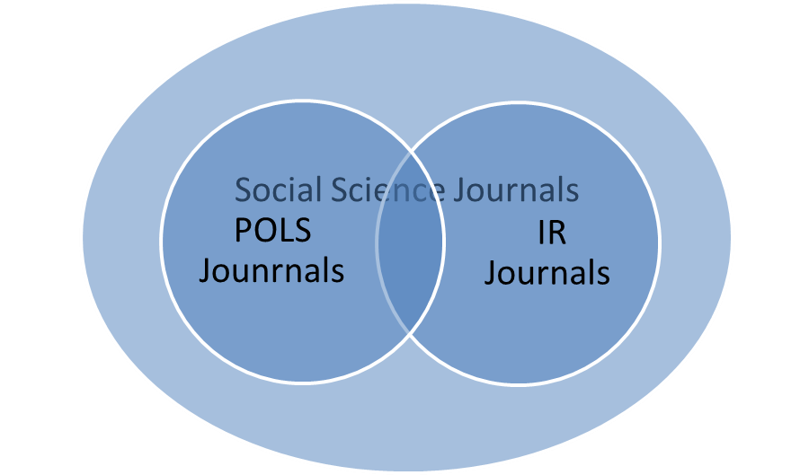

1. ***TRIP Citations (TRIP Cites)***
   1. Individual: This score represents the number of cites that an author received for articles published in journals listed as the top 21 most important journals in international relations.
   2. Department: This score is an average calculated by summing all of *TRIP Cites* for each scholar and then dividing that number by the number of IR faculty members in the department.
2. ***TRIP Citations Normalized (TRIP Cites N)***
   1. Individual: This score is calculated by taking the scholars *TRIP Cites* score and dividing it by the number of years since they received their PhD.
   2. Department: This score calculated by summing the *TRIP Cites N* for all members of the department and dividing it by the number of IR faculty members in the department.
3. ***TRIP h-index (IR Ex h-index)***
   1. Individual: This score represents the h-index generated by the distribution of citations that an author received for articles published in journals listed as the top 21 most important journals in international relations.
   2. Department: This score is calculated by summing all of the scholars’ *TRIP h-index* scores and dividing it by the number of IR faculty members in the department to produce an average h-index for the whole department.
4. ***TRIP h-index Normalized (TRIP Nh)***
   1. Individual: This score is calculated by dividing a scholar’s *TRIP h-index* score by the number of years since the scholar received their PhD.
   2. Department: This score is calculated by summing the *TRIP Nh* for all members of the department and dividing it by the number of IR faculty members in the department.
5. ***ProQuest Hits (ProQ)***
   1. Individual: This score calculated by searching all 442 IR scholars in the ProQuest Historical Newspaper database, which searches 18 major English Language Newspapers. We recorded the number of hits for a scholar, including articles authored, quotations, and mentions. We removed hits related to personal affairs, like wedding and birth announcements. The number of hits represents their ProQuest score (ProQ).
   2. Department: The ProQ scores of all of the IR scholars in the department were summed and divided by the number of IR scholars in the department. This produced an average ProQ score for the department, which was then used to rank the department.
6. ***ProQuest Hits Normalized (ProQN)***
   1. Individual: This score was calculated by dividing the IR scholar’s ProQ score by the number of years since PhD.
   2. Department: This score was calculated by summing the ProQN scores of all the IR scholars in the department and dividing them by the number of IR scholars in the department to produce a ProQN score for the department.
7. ***Book Score (Books)***
   1. Individual: In order to produce a score for book publications we employed the convention at the University of Notre Dame, whereby 1 book = 5 articles. The number of points that a book received out of five was determined by the rank out of 50 of its publisher, according to Garand & Giles (2011). A book published with a press ranked number 1 was given a score of 5, while a book published with a press ranked 18th was given a score of 3.33 out of 5. Once all a scholar’s books were scored they were summed to produce the scholar’s book score.
   2. Department: The Books score for the department was arrived at by summing all of the books scores of its IR scholars and dividing them by the number of IR scholars in the department. The average produced became the department’s book score.
   3. Summary of Book Scoring Method: (x/100) = [(n–1)/51] Where x is percentage lost, and n is publisher ranking. Here we equate the publisher ranking over total publishers to the percentage of points out of 100 which should be removed. We subtract 1 from n so that the scale begins at 0. (1–x)(5) = points awarded. The x value found previously is subtracted from 1 to give the proportion of points which will be retained. This is multiplied by 5 to yield final points. Simplified final formula [5 – (5/51)(n–1)].



1. ***Book Score Normalized (BooksN)***
   1. Individual: This score was calculated by dividing the IR scholar’s *Book* score by the number of years since PhD.
   2. Department: This score was calculated by summing the *BooksN* scores of all the IR scholars in the department and dividing them by the number of IR scholars in the department to produce a *BooksN* score for the department.
2. ***Foreign Affairs Publications (For Aff Pubs)***
   1. Individual: This score was arrived at by calculating how many articles an IR scholar had published in the journal Foreign Affairs. The number of articles became the scholar’s *For Aff Pubs* score.
   2. Department: This score was produced by summing the *For Aff Pubs* scores of all the IR scholars in the department and then dividing the sum by the number of IR scholars in the department. This generated the *Ave For Aff Pubs* score for each department.
3. ***Foreign Policy Publications (For Pol Pubs)***
   1. Individual: This score was arrived at by calculating how many articles an IR scholar had published in the journal Foreign Policy. The number of articles became the scholar’s *For Pol Pubs* score.
   2. Department: This score was produced by summing the *For Pol Pubs* scores of all the IR scholars in the department and then dividing the sum by the number of IR scholars in the department. This generated the *Ave For Pol Pubs* score for each department.
4. ***Council on Foreign Relations International Affairs Fellowships (CFR IAF)***
   1. Individual: This score was produced by seeing if a scholar had been offered an IAF through the CFR. This was done examining CVs and checking them against the CFR historical list of IAFs ([http://i.cfr.org/content/thinktank/IAF\_Historical\_List.pdf](http://i.cfr.org/content/thinktank/IAF_Historical_List.pdf" \t "_blank)). Scholars whose CVs showed they had declined a IAF were also counted. The reasoning being that it could not be determined why a scholar had declined in each case.
   2. Department: This score was generated by summing the *CFR IAF* scores of each IR scholar in the department and dividing the sum by the number of IR scholars in the department. This produced the department’s Ave CFR IAF score, which was then used to rank the departments.
5. ***Congressional Testimony (Cong Test)***
   1. Individual: Using the ProQuest Congressional database, the full record of congressional hearings was searched by witness name for each one of the 442 scholars in turn. This search yielded the names and dates of the hearings at which each individual gave testimony. A scholar was awarded 1 point for each hearing at which they testified.
   2. Department: the score for a department was obtained by averaging the total score of all the scholars.